A Minute for Membership – August 2022
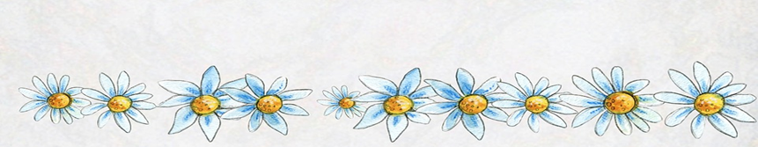

Does your chapter have a sister who sends out group messages, reminds sisters of upcoming events or meetings? If not, ask a sister who is tech savvy to be that point of contact. This way your President, Membership Chair, or anyone else can ask this person to send out their needed messages. This way changes to email addresses can be collated easily and this also helps ensure the message gets out. Here’s great first exercise for this very important person-ask them to send this “A Minute for Membership” out to each chapter sister. Remember that reaching out to sisters help them stay active in the chapter.

Are you stuck when thinking if you can help grow the chapter? Here’s an idea…review “Franc’s List” when thinking about who you could give the gift of P.E.O. You can ask your friends, relatives, acquaintances neighbors and children’s friends. You can see the complete “Franc’s List” activity on the P.E.O. International website: www.peointernational.org

Finally, are you looking for ideas for what your “1-minute for Membership” will be next time you meet. An excellent source is to look at our magazine The Record. Fun and interesting articles are presented each month; you can typically find a line or 2 to share in that meeting minute for membership.
Remember, the ME in membership is YOU!

Remember to go to our Alabama State PEO site and select the membership tab then click on unaffiliates to locate sisters in your area who need to be contacted about joining your chapter. www.peoalabama.org

