Chapter AI, Prattville is selling door hangers from Tabitha Smith, Zoo House Designs. If you are local in the Montgomery/ Prattville area, please contact Tabitha Smith to make arrangements for in-person delivery. These samples are only a few of the many designs she creates. Please contact Tabitha with any questions you may have regarding an order.

Name:________________________________________
Address:______________________________________
_______________________________________

Cell #:________________________

Item #:__________________________________________
Special Instructions(color, message, personalization):
_____________________________________________
_____________________________________________

How Paid:__________________

Date Delivered/Shipped:_________________

The cost is $30.00 each.

***Shipping costs are an additional $10.00.***

#1 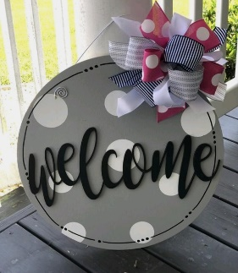 #2 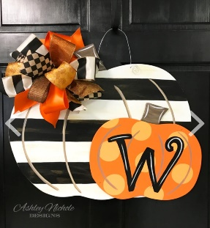 #3 #4 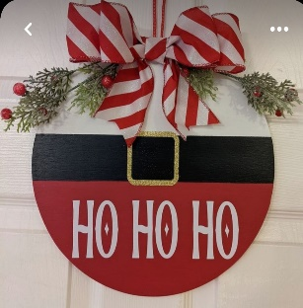
#5 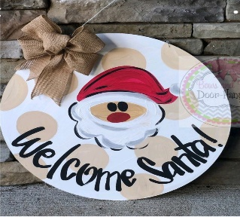 #6 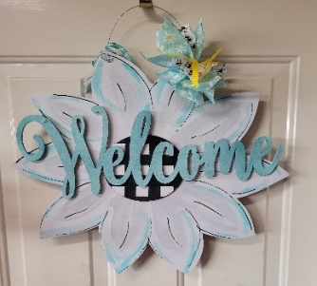 #7 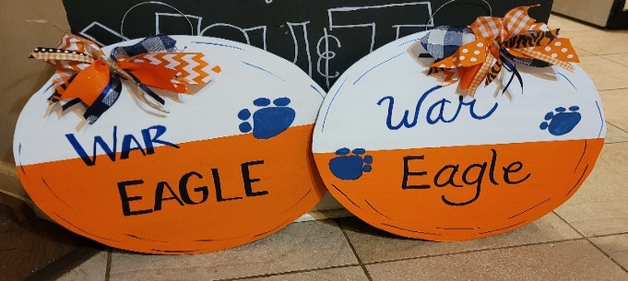
(#8-Alabama also available)

