A Minute for Membership - November 2022
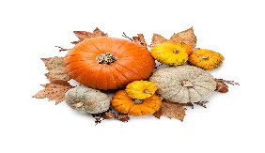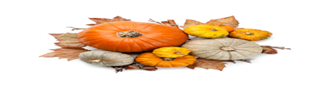
Days are getting shorter, and leaves are turning bright, gorgeous colors-holidays must be just around the corner. While we start celebrating the wonderful events of the season, let’s also continue to reconnect with sisters who haven’t been as active as perhaps, we would like them to be, find some new sisters and reach out to our inactive sisters. Here are some helpful tips to help with this!
- Investigate what the sister’s situation might be--see where you can help.
- Establish communications with her and include a “loving concern”.
- Encourage her to participate in your chapter’s small groups, outing and lunch dates. (This is a good time to let the inactive sisters have a chance to see her old friends.)
- Send notes to sisters who are “Missing in Action”.
- Contact your Inactive members regularly.
- Drop by with a small gift or token of care to these sisters.
- Offer rides to chapter meetings (those who are active) and follow up before “Your Date”.
Also, in this month’s Record there is a great membership article. Cause and Effect: The Benefits of Reaching out to Inactive and Unaffiliates P.E.O.s by Rita Briggs, Chair, P.E.O. International Membership Committee. p.19. Check it out!
Finally, although our Zoom Membership Training Workshops are complete, stay tuned for the recorded version to be posted at www.peoalabama.org. The slides will be there too! Please let your state membership representative know if you need help or information. We are here to help with all your membership questions.
Remember…every day is a good day to introduce a woman to P.E.O. Help friends, relatives, and acquaintances “Live in a P.E.O. World----Imagine!”

*Please share this Minute for Membership with all chapter members!

