Sunday | Monday | Tuesday | Wednesday | Thursday | Friday | Saturday
 |  |  |  | 1 | 2 | 3
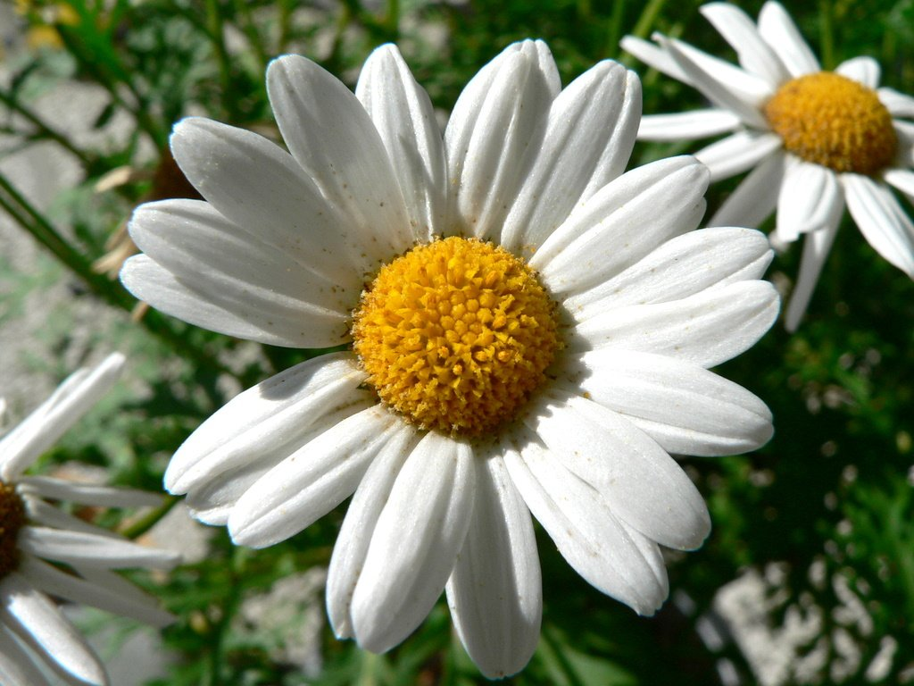 |  | July 2021  Thankful for…  PEO Ways and Means, Ch M |  | Gardens--.25 if you tend a garden, .50 if you do not | ^{Veterans--}  .25 if you know 5 Veterans, .50 if not | Celebration-.25 if you have watermelon to celebrate July 4th, .50 if not
4 | 5 | 6 | 7 | 8 | 9 | 10
The Fourth of July—.25 if you are hosting the celebration, .50 if you not | ^{Sisters---}  .25 for each biological sister you have | Books-- .25 if you read a book in the last month, .50 if not | Neighbors-.10 if you talked to a neighbor this week, .25 if you did not | Brothers—.25 for each biological brother you have | Founding Fathers---.25 to name six, $1 if you cannot | Mothers--.50 if you are named after your mother, $1.00 if you are not
11 | 12 | 13 | 14 | 15 | 16 | 17
Church--.25 if you attended a church service today, .50 if not | Our Armed Services--.25 if a Veteran is in your family, .50 if not | Washing machines--.10 for each load of laundry done in the past week | Pets--.25 for each pet in your household | Children--.10 for each child, .25 for each grandchild | Clothing--.25 for each black skirt or dress or pants you have | Vision--.10 if you wear glasses or contacts, .25 if you do not
18 | 19 | 20 | 21 | 22 | 23 | 24
Freedom of Religion--.25 if you attended church service today, .50 if not | Health--.25 if you exercised today, .50 if you did not | Travels-.25 for each time you travelled out of the country in your life | PEO--.25 if you attended PEO today, .50 if you did not | Health--.10 if you took a vitamin today, .50 if you did not | Transportation-.10 for each four-wheel vehicle in your household | Friends--.25 if you reached out to a friend this month, .50 if you did not
25  Church Family--.25 if you attended a church service today, .50 if not | 26  Travels--.50 if you traveled out of state in 2021, .25 if you not | 27  PEO--.25 if you read the July PEO Record, .50 if not | 28  Health--.25 if you had your flu or Covid shot this year, .50 if not | 29  Transportation- .25 if your automobile is 2019 or newer, .50 if it is not | 30  God’s Word--.10 for each Bible in your household | 31  Saturdays--.25 if you relaxed today, .50 if you did not

